3-1 Milestone Database Indexing and Authentication

Cristiano Miranda
Southern New Hampshire University
CS-340: Client/Server Development
Professor Badam
22 March 2026

3-1 Milestone Database Indexing and Authentication
Part One:
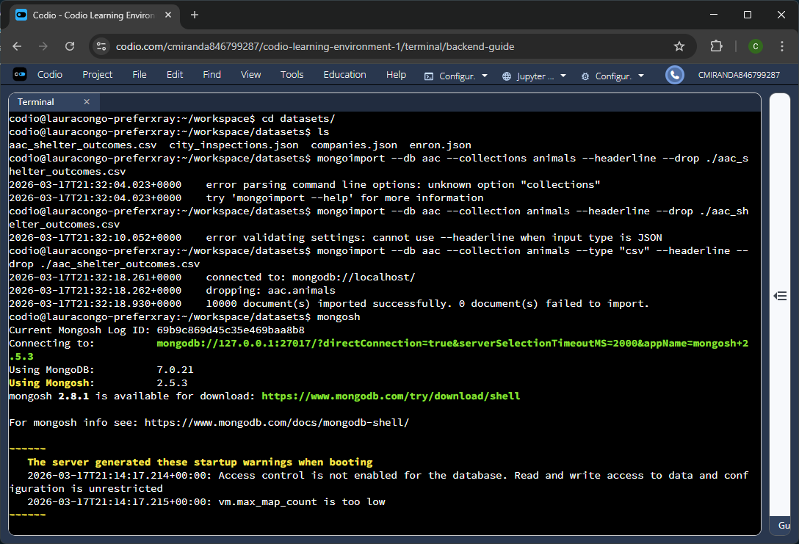
Figure 1A – Importing the “aac_shelter_outcomes.csv” file into the “aac” database.
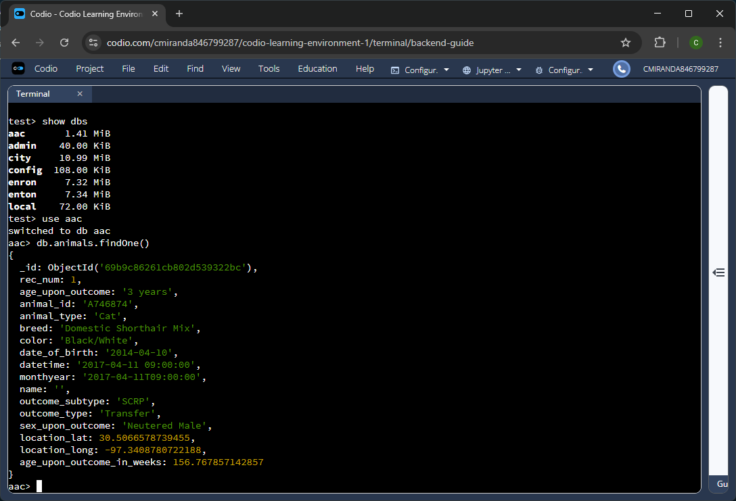
Figure 1B – Using the show command to display the newly added database and using the findOne() command to confirm the entries were properly imported.
The first step to working with this data was to import it into a database using the mongoimport command. To properly import from a csv file, the “—type“ flag was added to specify the type as “csv,” and to properly assign the first line of the csv file as the various keys for the different entries the “—headerline" flag was added as well. The remaining flags “—db" and “—collection" are used to specify of the data base name and the collection name respectively, and the last flag, “—drop,” was added to drop any preexisting data associated with the specified database and collection.
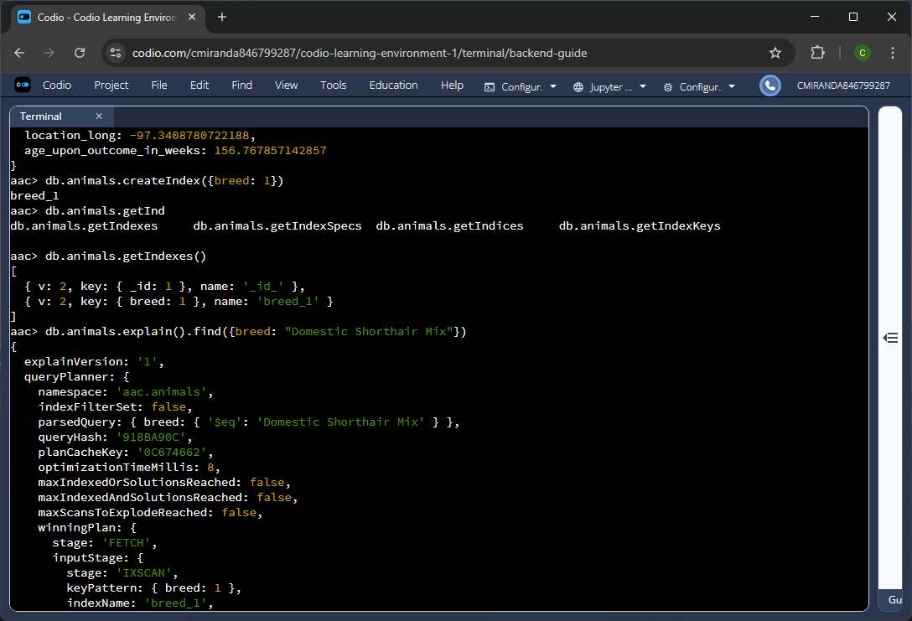
Figure 2A – Creating an index for the “breed” key and using the command to retrieve indexes to validate its creation. Also, the explain command was used in tandem with the find command to validate that the query utilized the newly created index.
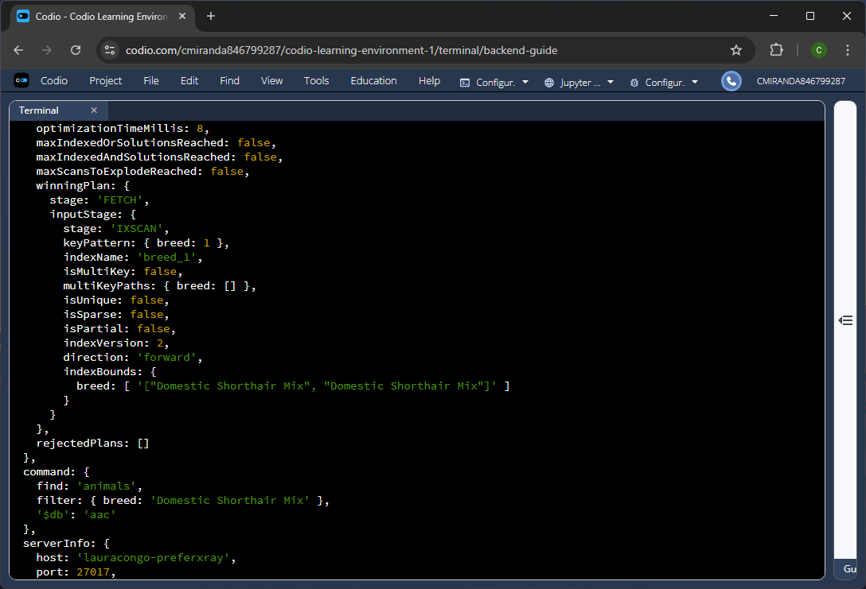
Figure 2B – Confirmation that the query used the index as shown in the returned winningPlan object.
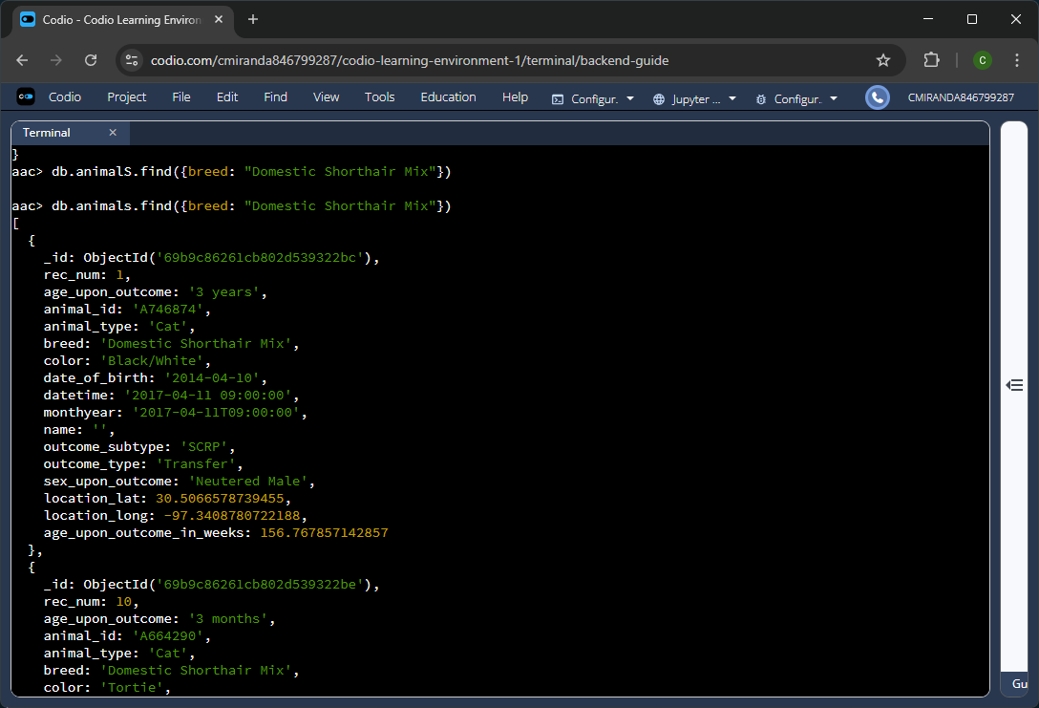
Figure 2C – Running the query without the explain command returns the expected results, which is all entries whose “breed” match “Domestic Shorthair Mix.”
Creating an index for the “breed” key allows for faster searching for queries, as it is common to search based on breeds for adoption animals. First, a check was made to confirm the index was successfully created and then a check was made to confirm that the index was being utilized for queries by using the explain command and interpreting its output. Viewing its output, specifically the “winningPlan” object, shows that the query finished while scanning index keys and specifically, the index named “breed_1,” which is the newly created index and confirms that the index is properly functioning.
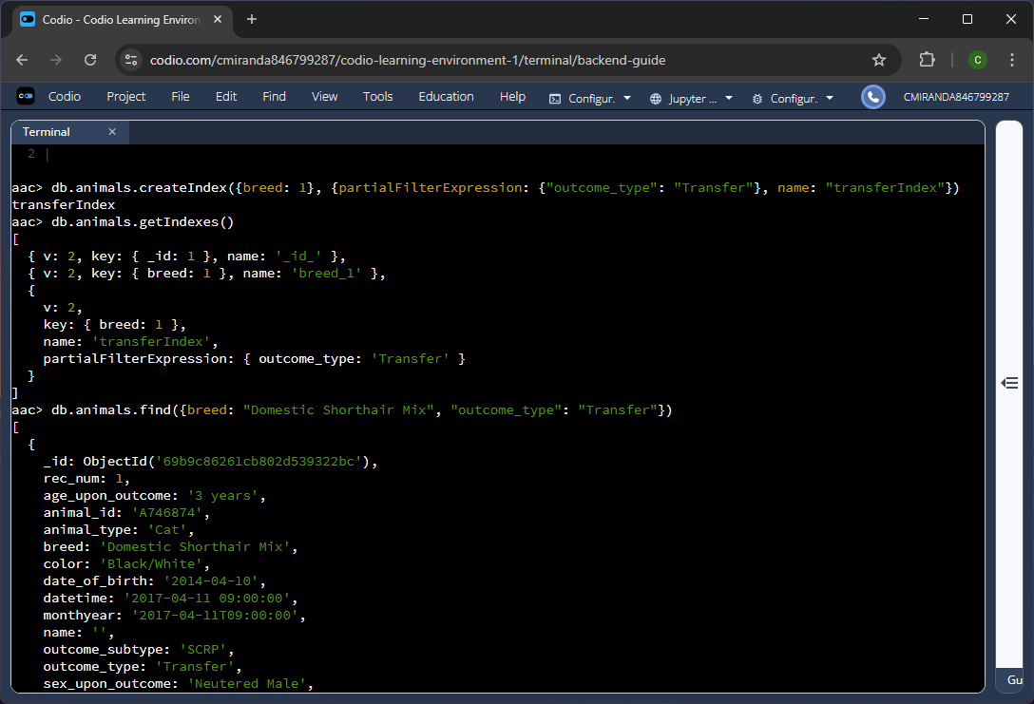
Figure 3A – Creation of a compound index for the “breed” key and “outcome_type” key when the value specifically equals “Transfer.” A query is run to retrieve all data who has a “breed” of “Domestic Shorthair Mix” and whose “outcome_type” equals “Transfer.”
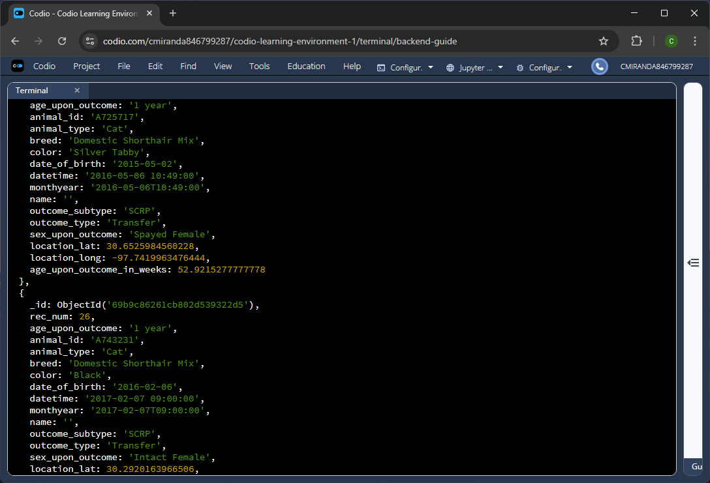
Figure 3B – Further return output from the query.
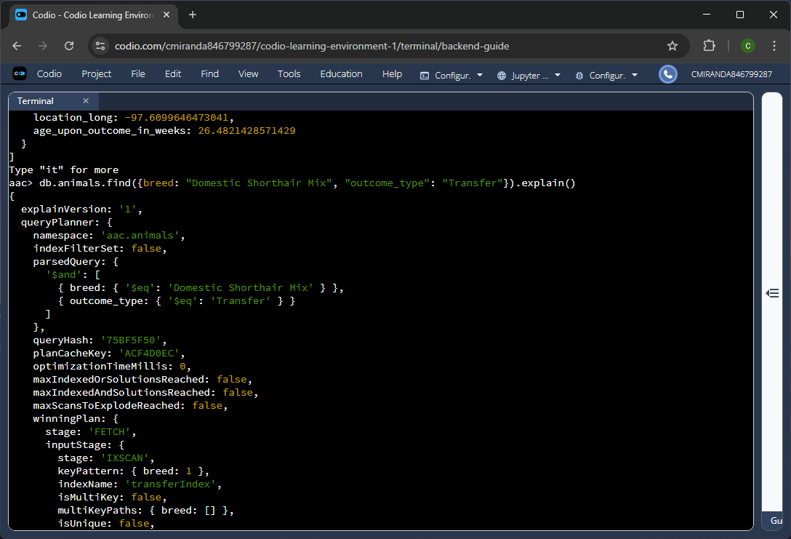
Figure 3C – Using the explain command on the query to confirm it is using the newly created index.
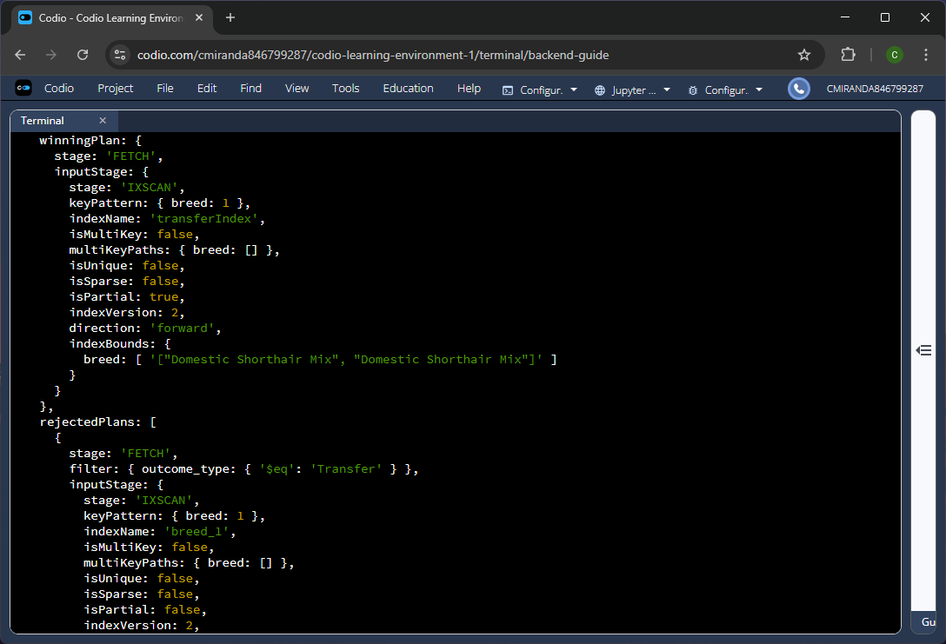
Figure 3D – Confirmation that the “transferIndex” was used to retrieve this query’s results.
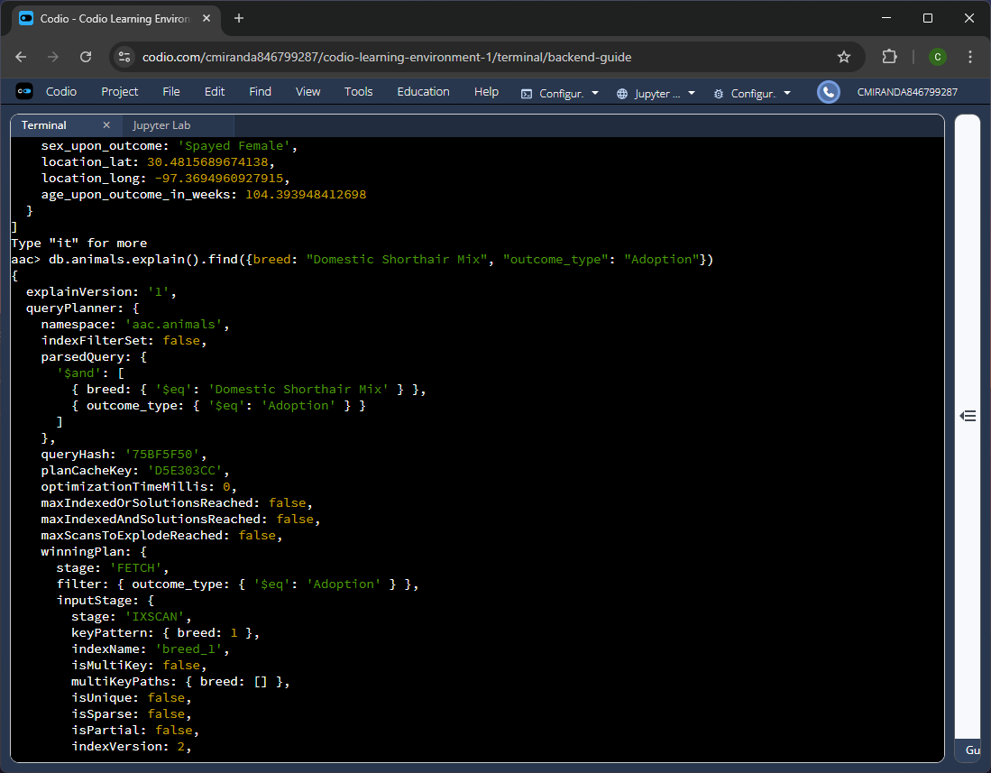
Figure 3E – Rerunning the query but passing in a different “outcome_type” value to confirm that the created index functions only with the specified “outcome_type” used during the index creation.
Along with regularly searching for animal breeds, it is also common that places would look for animals with a specific status in the system. In this case, the “Transfer” status was used along with the “breed” key to create a compound index to speed up searches relating to both keys. Like with the first index, the same command createIndex() was utilized, but a second object was passed. In this second object, the “partialfilterEpxression” key was provided with another object that specified the “outcome_type” key equals “Transfer.” In doing so, the compound index was created and is used for queries that filter by the “breed” key and specifically, an “outcome_type” key with a value of “Transfer.” Additoinally, within this second object, the “name” key was also used and provided with a string containing the name of the new index to make it easier to identify. The explain command was used to validate the index’s functionality, and the output showed that the transferIndex was used for the query. To further confirm this, another query was run but the “outcome_type” key was set with a value of “Adoption” and the explain output confirms that in this instance, the index “breed_1” was used instead.

Part Two:
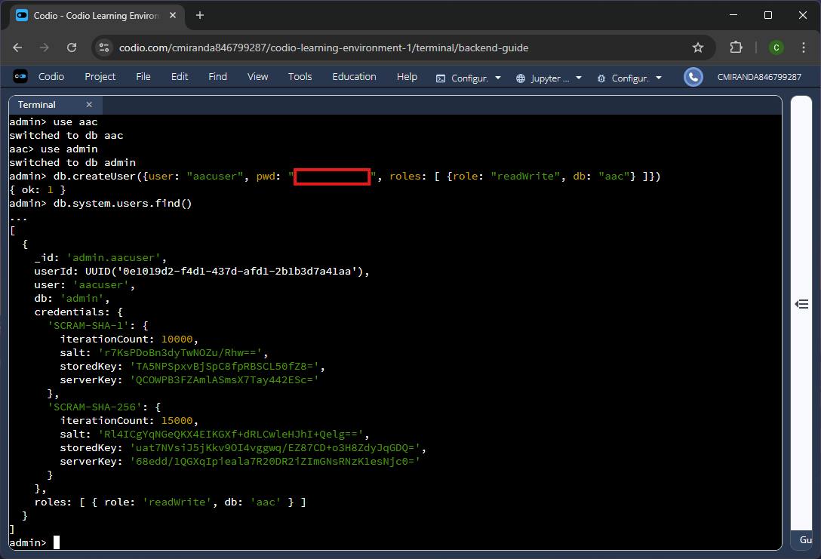
Figure 4 – Creating a new database account with the username “aacuser” and providing them with access to the “aac” database only.
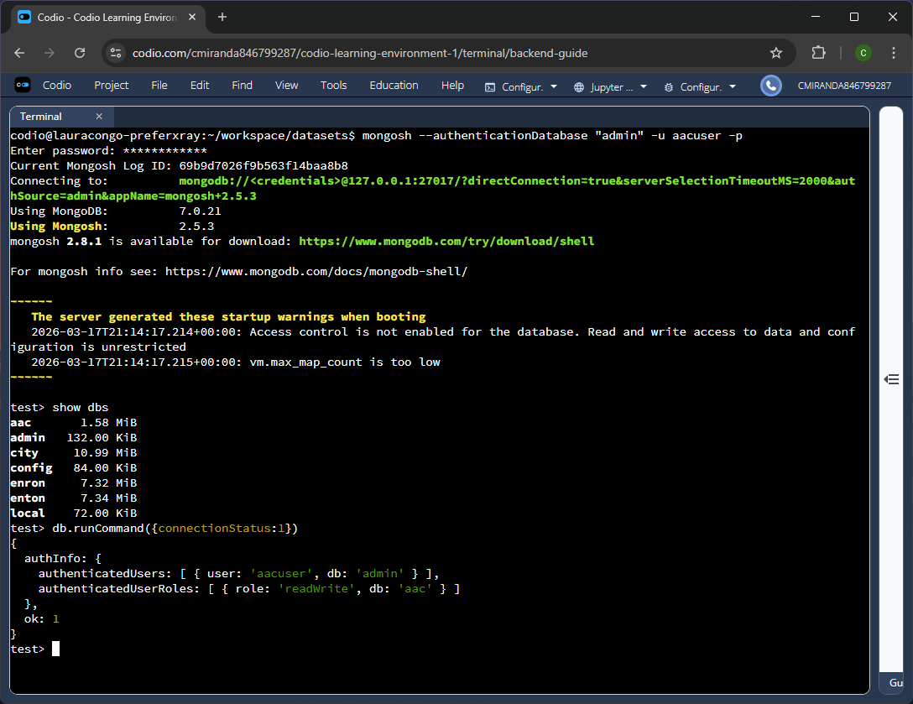
Figure 5 – Connecting to the database using the new account “aacuser” and running the command to validate the current connected user was created with the proper roles.
Further protections were warranted for the database, and to start, the use of a non-administrative account for writing and reading from the “aac” database was necessary as this greatly reduces the potential damage an unauthorized can do to the whole database system if they gained access to the account. Creating the account entailed the use of the createUser() command and passing in the necessary data for the account, like the username, password, and the permissions it would have. Afterwards, the account was used to connect to the database, and a command was run to confirm that the account was created with the appropriate role specifications.

